Assignments 10

1. Write a query that produces all pairs of salespeople who are living
in the same city. Exclude combinations of salespeople with themselves
as well as duplicate rows with the order reversed.

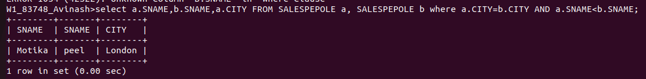

2.Write a query that produces the names and cities of all customers
with the same rating as Hoffman.

